CA22 - PRACTICE PROBLEMS – WEEK 3
- It is found that a program has 75% of its calculations that can be parallelized. Compute the speedup observed on a 4 processor system. Also compute the maximum theoretical speedup possible for the program.

1.a. 1 / ( 0.25 + 0.75/4) = 2.29
1.b. 4

2.
Translate given C code into MIPS instructions
a. f=(a-b-c)
b. f=(a+(b-c))-(e-d)
Assume that variable a to f are present in $S1 to $S6
c. a = b && (c > d)
Assume the following register mappings (a: t0, b:t1, c:t2, d:t3)
Sol:
For a. sub $S1, $S1, $S2
sub $S1, $S1, $S3
move $S1, $s6
For b. sub $t0, $s2, $s3
Add $t1, $s1, $t0
Sub $t2, $s5, $s4
Sub $t3, $t1, $t2
move $t3, $s6
For c. li $t0, 0 # assume a if false
beq $t1, $0, L1 # if b is false then L1 (a is false)
ble $t2, $t3, L1 # if ( c < d) then L1 (a is false)
li $t0, 1 # b && (c > d) is true, so a is true(1)
L1:…

3. Represent the following MIPS instructions in MIPS machine code (hexadecimal)
- addi $s0, $t1, 64
- sll $t2, $t3, 16
- lw $t4, 32($s1)

MIPS Instructions Formats
R-format | 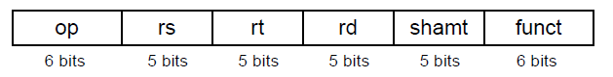 | Opcodes:  addi: (op=8)  sll: (op=0, funct=0)  lw: (op=0x35) | 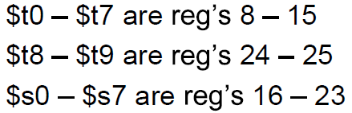
I-Format | 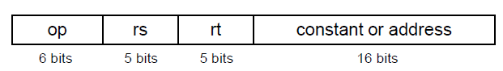

Sol:
i) I format - 21300040H
ii) R format - 000B5400H
iii) I format - 8E2C0020H

4. Suppose register $s0 has the binary number 1111 1101 1111 1110 1111 1010 1111 1111 and register $s1 has 0000 0000 0000 0100 1100 0010 0000 0001 what are the values of registers $t0 and $t1 after these two instructions?
sll $t1, $s0,4
srl $t0, $s1,4
Sol:
sll $t1, $s0, 4
1101 1111 1110 1111 1010 1111 1111 0000 = 3757027312‬, -537939984‬‬‬‬‬‬‬
srl $t0, $s1,4
0000 0000 0000 0000 0100 1100 0010 0000 = 19488

5. Find the content of register $t0 after executing the following command.
or $t0, $t1, $t2
Assume $t1= (21467865)₁₀ and $t2= (efdcaabb)_{H}
Sol:
0000 0001 0100 0111 1001 0010 1101 1001
1110 1111 1101 1100 1010 1010 1011 1011‬
----------------------------------------
1110 1111 1101 1111 1011 1010 1111 1011
---------------------------------------------------------
(EFDFBAFB‬)H‬‬‬‬‬‬‬

